Connecting mysql database using GUI base

**mysql workbench :** it is open source software which help to connect the database.

<https://dev.mysql.com/downloads/workbench/>

after installed you need to open workbench

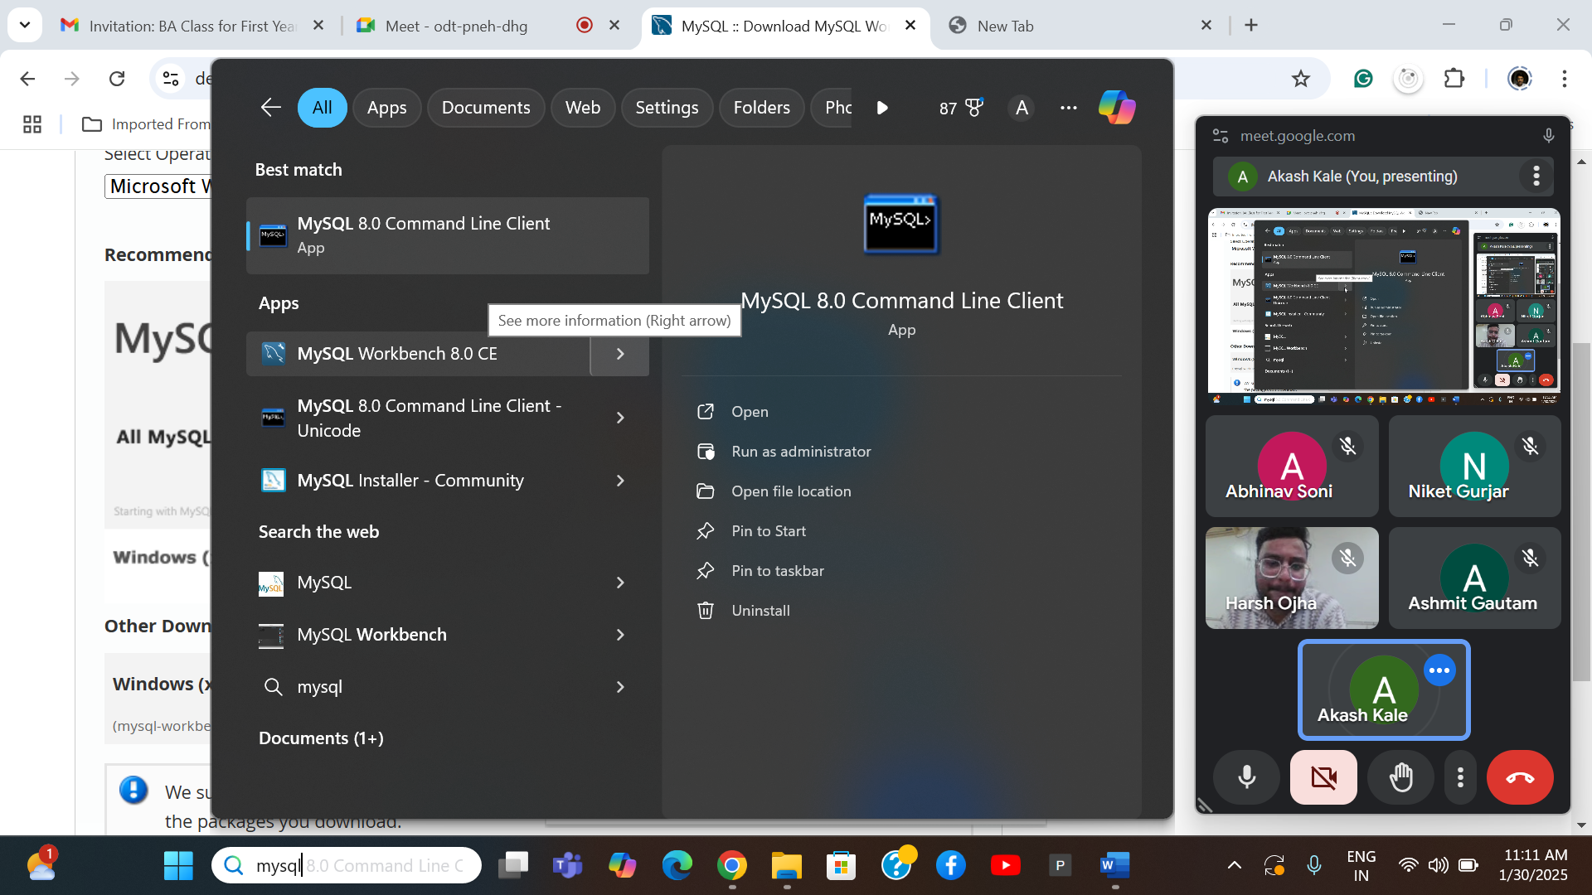

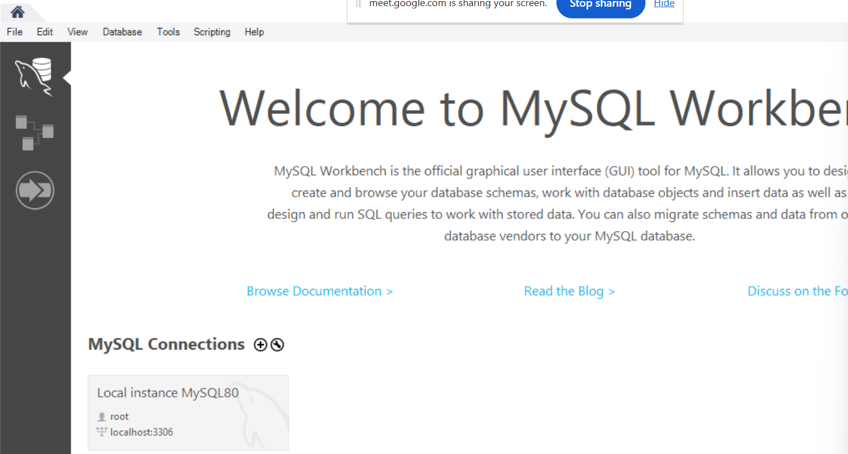

Once open select the database menu option and select connect database sub option.

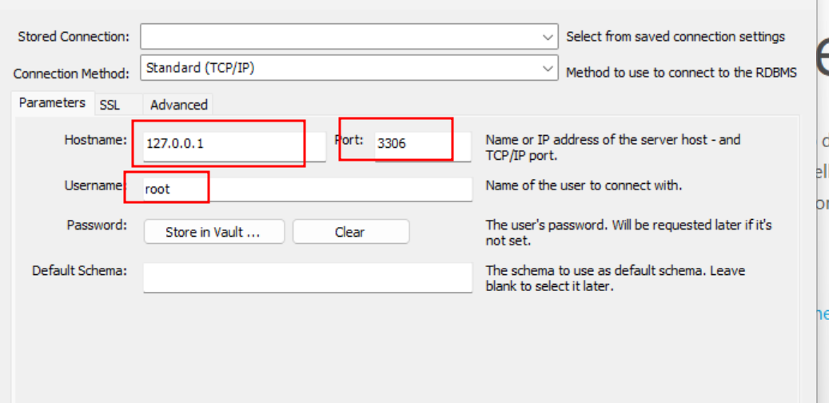

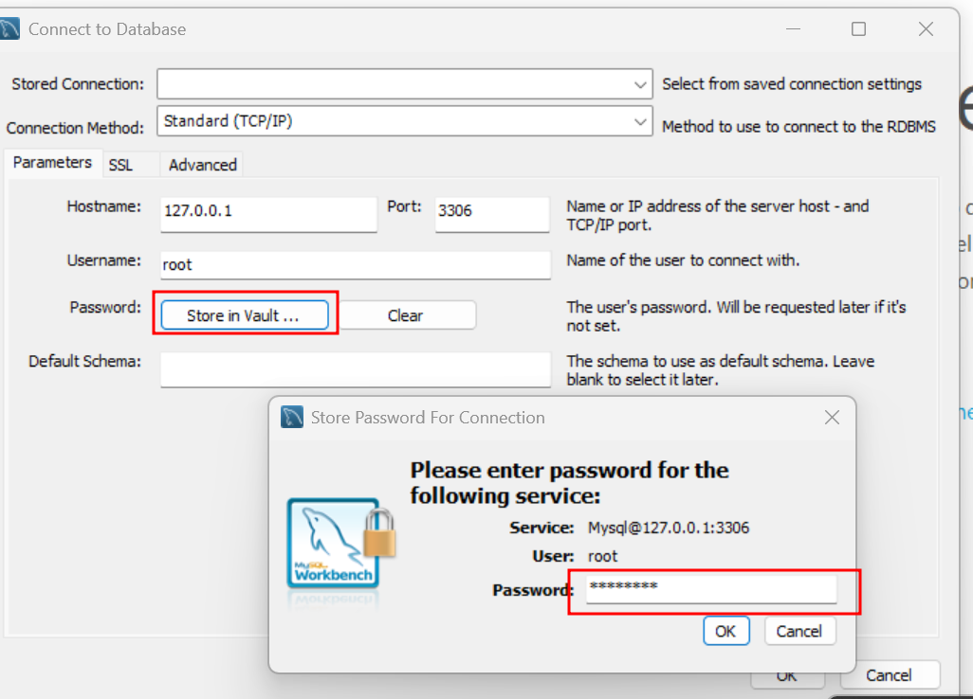

After provided password please click on ok button and check database connected or not.

One to many relationship with **Trainer and Students**

1 many

Student

Trainer

**Trainer --🡪 Table**

TId -🡪 int , pk

TName 🡪 varchar(30) not null

Tech -🡪 varchar(30) default ‘Python’

**Student -🡪 table**

Sid 🡪 int, pk auto_increment

SName 🡪varchar(30) not null

Age 🡪 int , we apply check constraint with age must be > 21

TsID 🡪 int FK connect to Pk for trainer table ie tid

USE isbm_db;

SHOW TABLES;

CREATE TABLE trainer (

tid INT PRIMARY KEY,

tname VARCHAR(30) NOT NULL,

tech VARCHAR(30) DEFAULT 'python'

);

insert into trainer(tid,tname) values(1,'Ravi');

insert into trainer(tid,tname) values(2,'Ramesh');

insert into trainer(tid,tname,tech) values(3,'Rajesh','MySQL');

insert into trainer(tid,tname,tech) values(4,'Raj','Java');

select * from trainer;

CREATE TABLE students (

sid INT PRIMARY KEY AUTO_INCREMENT,

sname VARCHAR(30) NOT NULL,

age INT CHECK (age > 21),

tsid INT,

FOREIGN KEY (tsid)

REFERENCES trainer (tid)

);

insert into students(sname,age,tsid) values('Seeta',27,1);

insert into students(sname,age,tsid) values('Veeta',25,2);

insert into students(sname,age,tsid) values('Meeta',26,1);

insert into students(sname,age,tsid) values('Veeta',22,3);

insert into students(sname,age,tsid) values('Leeta',24,4);

insert into students(sname,age,tsid) values('Keeta',22,5);

select * from students;